User Guide

Deep Learning for Lymphoid Malignancies
Jacinda Garcia
Grand Canyon University
06/2025

User Guide: Lymphoid Malignancy Diagnostic Assistant
A deep learning Application for Histopathology Slide Analysis

Copyright and Legal Information
Medical Disclaimer: This is project is for research investigation only and should not be used to make clinical decisions.
The data used contains no patient information and was extracted from a public dataset that can be found here: https://www.kaggle.com/datasets/andrewmvd/malignant-lymphoma-classification

Preface
The purpose of this guide is to demonstrate how to use the diagnostic application.

General Information
- What is the Application?
  - AI-based tool for predicting lymphoma subtype from pathology slide tiles
- Key Features
  - Upload & Analyze Patches
  - AI-Based Prediction (ResNet-50)
  - Grad-CAM Visualization
  - Downloadable PDF Reports
- System Requirements
  - Browser and Device Compatibility
  - Supported Operating Systems
- Accessibility Support
  - High-contrast mode
  - Screen reader-friendly layout
  - Keyboard-only navigation

System Summary
- Overview of Workflow
  - Input: Tile images
  - Process: Deep learning inference
  - Output: Subtype prediction, Grad-CAM map, PDF report
- Architecture Diagram
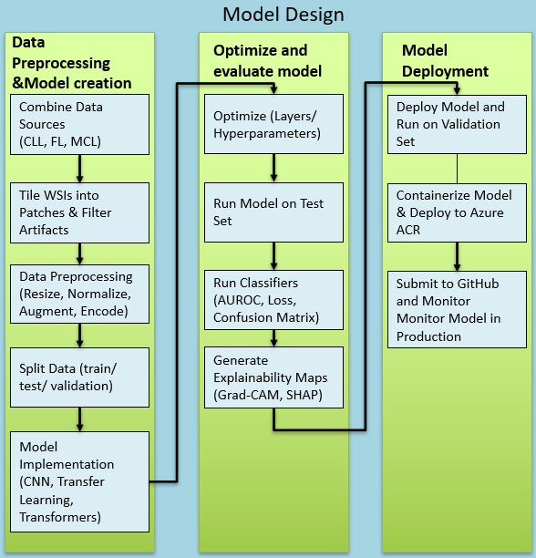
- Technology Stack
  - Streamlit, PyTorch, OpenSlide, Docker, Azure (optional)

Getting Started

Installation
For Web App Users
- No installation required.
- Access the app directly via browser:
https://lymphoid-streamlit-app.azurewebsites.net
For Local Users (Advanced)
To run locally:
- Download the Repository
  - Clone from GitHub:
bash
CopyEdit
git clone https://github.com/yourusername/lymphoid_malignancy_platform.git
- Install Python 3.10+
- Create and Activate Virtual Environment
bash
CopyEdit
python -m venv env
source env/bin/activate # macOS/Linux
.\env\Scripts\activate # Windows
- Install Requirements
bash
CopyEdit
pip install -r requirements.txt
- Run the App
bash
CopyEdit
streamlit run streamlit_app.py
Alternatively, run the Docker container:
bash
CopyEdit
docker build -t lymphoid-app .
docker run -p 8501:80 lymphoid-app

Troubleshooting Install Issues
Issue | Cause | Solution
streamlit not found | Virtual environment not activated | Activate environment first
Docker build fails | Missing system dependencies | Ensure Docker is installed, try rebuilding
Image load error | Path or format issue | Use .jpg, .png, or .tif format tiles only

First-Time Setup

Loading Sample Data
- In Demo Mode, built-in images will walk you through how the model works.
- In Interactive Mode, you may:
  - Upload .jpg, .png, or .tif files
  - Paste a public image URL

Navigating the Interface
- Use tabs across the top:
  - Demo Mode: Training pipeline walkthrough
  - Interactive Mode: Upload, classify, visualize, and download reports
  - Help: Usage instructions, tips, and accessibility info

Accessibility Settings
- In the sidebar:
  - Toggle “High-contrast mode” for better visibility
  - System reports whether it's running on GPU or CPU

Using the System
Demo Mode
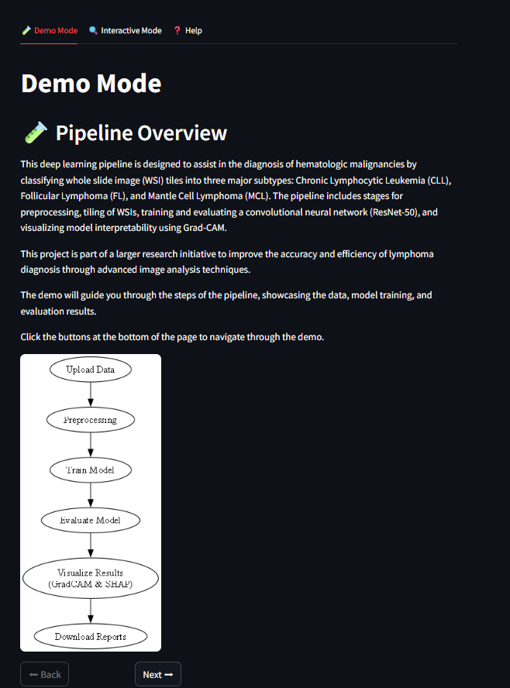
This mode guides you through:
- Pipeline Overview – Flowchart explaining the process
- Raw Data – Example whole-slide images
- Tiles – How images are cropped and labeled
- Training – Augmented tiles and ResNet-50 setup
- GradCAM – Visual explanation of model attention
- Evaluation – Confusion matrix and ROC-AUC curve
Navigation: Use the “Next” and “Back” buttons to walk through the sections.

Interactive Mode
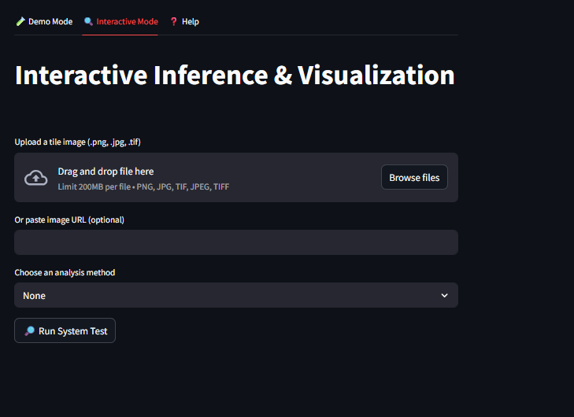
Uploading or Linking Images
- Upload .jpg, .png, .tif images
- Or paste a public image URL
Analyzing a Case
Once an image is uploaded:
- It is preprocessed, tiled, and passed through the trained ResNet-50 model.
- A prediction is returned for one of:
  - Chronic Lymphocytic Leukemia (CLL)
  - Follicular Lymphoma (FL)
  - Mantle Cell Lymphoma (MCL)
- The following analytics are displayed:
  - Descriptive Statistics (Mean [RGB], Median [RGB], Standard Deviation [RGB])
  - Prediction and confidence score
  - Grad-CAM image
  - RGB Histogram
  - Pixel Intensity Distribution
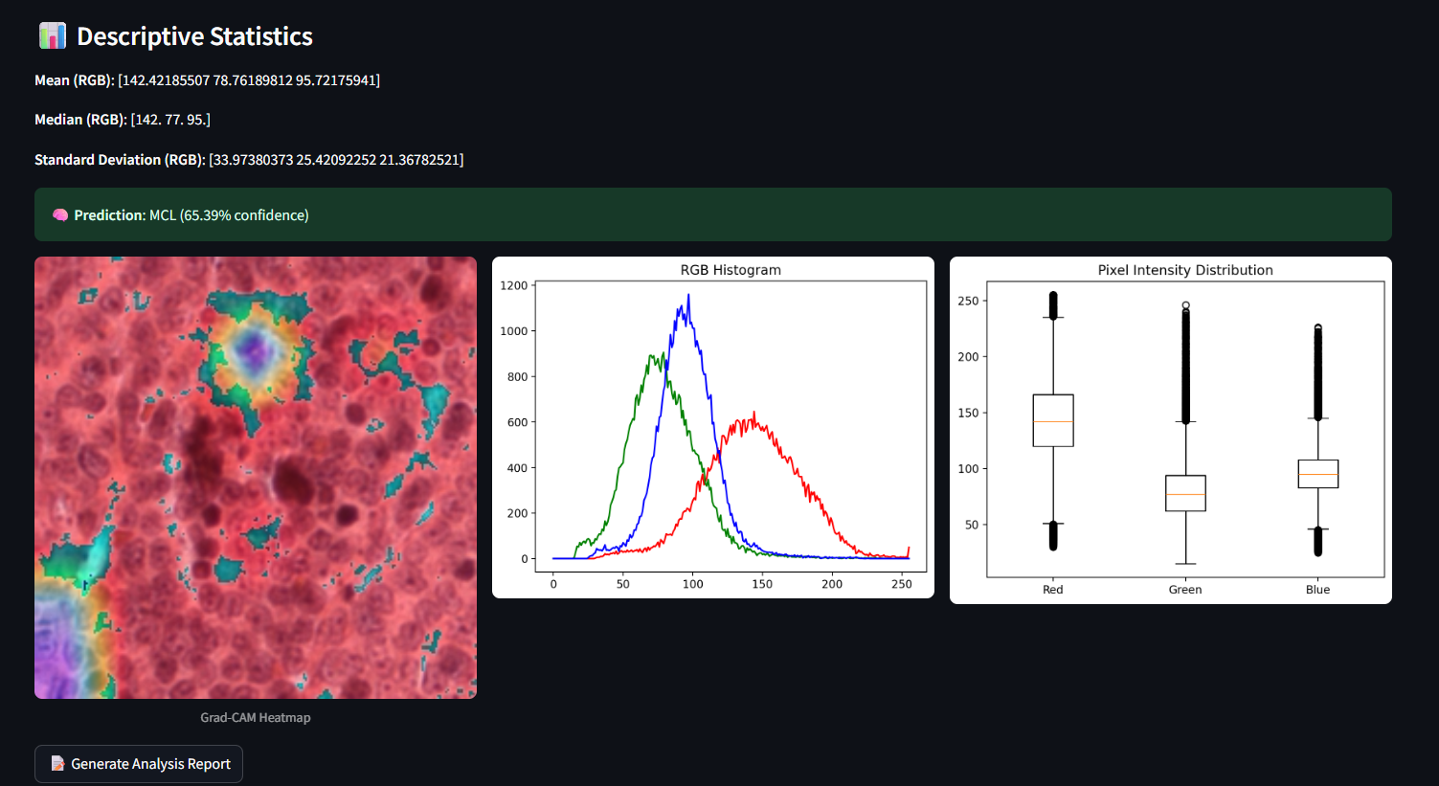
Downloading Reports
- Click “Generate Analysis Report”

- Generates a PDF with:
  - Original uploaded image
  - Grad-CAM heatmap
  - Image statistics and plots
  - Prediction and confidence
Note: All data is processed in memory — no data is stored

Troubleshooting
Issue | Possible Cause | Solution
App not loading | Browser blocked scripts or Azure down | Refresh browser or check deployment logs
Grad-CAM failed | Image too small or unsupported layer | Use 224x224 tile; re-upload
PDF export fails | Missing reportlab or file permissions | Reinstall required packages, check local path
No prediction returned | Model or file load error | Ensure valid image, model weights exist
“Tile too small” | Uploaded image is smaller than 224x224 | Upload a larger or correctly-sized tile

Frequently Asked Questions (FAQ)
Can I use whole-slide images (.svs, .tif)?
Yes, the pipeline will process your whole slide image into tile.
Is this tool FDA-approved?
No. This tool is for research and educational use only, not clinical diagnosis.
Can I retrain the model?
Yes. Use train_model.ipynb to retrain on your own dataset, or use the CLI training pipeline in scripts/train_utils.py.

Help and Contact Details
Contact: JGarcia641@my.gcu.edu
GitHub Repository: https://github.com/Jacinda-G/-lymphoid-malignancy-classification

Glossary
Term | Description
Tile | A small image patch cropped from a histopathology slide
Grad-CAM | Visualization tool showing model focus
ResNet-50 | Deep convolutional neural network architecture
Subtype | A classification of lymphoid malignancy
CLAHE | Contrast Limited Adaptive Histogram Equalization

